**Practice 1**

**Part 1**

1. The following SELECT statement executes successfully:

SELECT last_name, job_id, salary AS Sal  
 FROM employees;

True/False

**🡪 True**

2. The following SELECT statement executes successfully:

SELECT *

FROM job_grades;

True/False

**🡪 False**

3. There are four coding errors in the following statement. Can you identify them?

SELECT employee_id, last_name

sal x 12 ANNUAL SALARY

FROM employees;

* **SELECT employee_id, last_name,**

**salary * 12 "ANNUAL SALARY"**

**FROM employees;**

**Part 2**

You have been hired as a SQL programmer for Acme Corporation. Your first task is to create some reports based on data from the Human Resources tables.

4. Your first task is to determine the structure of the DEPARTMENTS table and its contents.

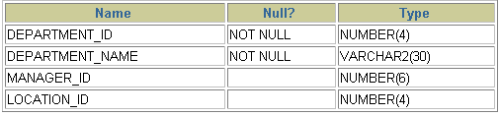

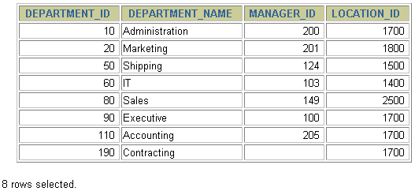

🡪 **describe departments;**

**5. You need to determine the structure of the EMPLOYEES table.**

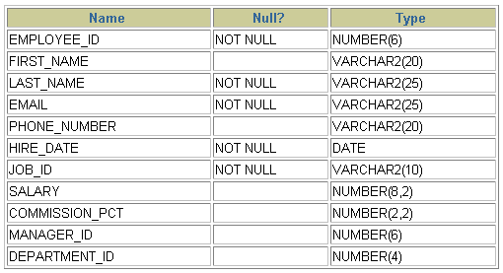

The HR department wants a query to display the last name, job code, hire date, and employee number for each employee, with employee number appearing first. Provide an alias STARTDATE for the HIRE_DATE column.

🡪 **describe employees;**

1. **The HR department needs a query to display all unique job codes from the EMPLOYEES table.**

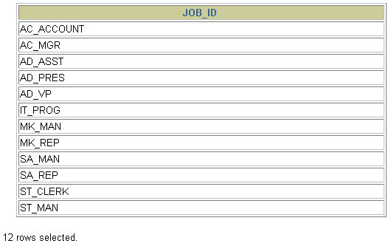

----🡪 select distinct job_id from employees;

1. **The HR department wants more descriptive column headings for its report on employees. Name the column headings Emp #, Employee, Job, and Hire Date, respectively. Then run your query again.**

--🡪 **SELECT employee_id “Emp #”, last_name “Employee”, job_id “Job”, hire_date “Hire Date’ FROM employees;**

1. **The HR department has requested a report of all employees and their job IDs. Display the last name concatenated with the job ID (separated by a comma and space) and name the column Employee and Title.**

**--🡪 select last_name||','||job_id as "Employee and Title"**

**from employees;**

1. **To familiarize yourself with the data in the EMPLOYEES table, create a query to display all the data from that table. Separate each column output by a comma. Name the column title THE_OUTPUT.**

**-🡪 select employee_id||','||first_name||','||last_name||','||email||','||phone_number||','||hire_date||','||job_id||','||salary||','||commission_pct||','||manager_id||','||department_id as "The Output"**

**from employees;**